ONLINE LEARNING PLATFORM WITH ADAPTIVE LEARNING
(Database Management System Capstone Project)
DHRUV
2401010131

System Overview:
This system connects students, courses, and assessments in an online learning environment.
Students enroll in courses and complete assessments. Based on their performance, the system tracks progress and suggests personalized learning paths.
The system continuously monitors student performance and helps improve learning outcomes.

Objectives:
- To design a database for online learning system
- To manage students, courses, and assessments
- To track student progress efficiently
- To provide adaptive learning recommendations
- To improve learning experience

SQL Queries:
CREATE DATABASE OnlineLearningDB;
USE OnlineLearningDB;

-- STUDENTS
CREATE TABLE Students (
student_id INT PRIMARY KEY,
name VARCHAR(50) NOT NULL,
email VARCHAR(100) UNIQUE NOT NULL
);

-- COURSES
CREATE TABLE Courses (
course_id INT PRIMARY KEY,
course_name VARCHAR(50) NOT NULL,
difficulty_level VARCHAR(20)
);

-- ENROLLMENTS
CREATE TABLE Enrollments (
enroll_id INT PRIMARY KEY,
student_id INT,
course_id INT,
progress INT CHECK (progress BETWEEN 0 AND 100),
FOREIGN KEY (student_id) REFERENCES Students(student_id),
FOREIGN KEY (course_id) REFERENCES Courses(course_id)
);

-- ASSESSMENTS
CREATE TABLE Assessments (
assessment_id INT PRIMARY KEY,
course_id INT,
max_marks INT,
FOREIGN KEY (course_id) REFERENCES Courses(course_id)
);

-- RESULTS
CREATE TABLE Results (
result_id INT PRIMARY KEY,
student_id INT,
assessment_id INT,
marks INT,
FOREIGN KEY (student_id) REFERENCES Students(student_id),
FOREIGN KEY (assessment_id) REFERENCES Assessments(assessment_id)
);

-- INSERT DATA

-- STUDENTS
INSERT INTO Students VALUES
(1, 'Gaurav', 'gaurav@gmail.com'),
(2, 'Dhruv', 'dhruv@gmail.com'),
(3, 'Aman', 'aman@gmail.com');

-- COURSES
INSERT INTO Courses VALUES
(1, 'DBMS', 'Beginner'),
(2, 'AI', 'Advanced'),
(3, 'Python', 'Intermediate');

-- ENROLLMENTS
INSERT INTO Enrollments VALUES
(1, 1, 1, 60),
(2, 2, 2, 80),
(3, 3, 3, 30);

-- ASSESSMENTS
INSERT INTO Assessments VALUES
(1, 1, 100),
(2, 2, 100),
(3, 3, 100);

-- RESULTS
INSERT INTO Results VALUES
(1, 1, 1, 45),
(2, 2, 2, 85),
(3, 3, 3, 25);
SHOW TABLES;

SELECT * FROM Students;
SELECT * FROM Courses;
SELECT * FROM Enrollments;
SELECT * FROM Assessments;
SELECT * FROM Results;

-- 1. STUDENT PROGRESS
SELECT s.name, c.course_name, e.progress
FROM Students s
JOIN Enrollments e ON s.student_id = e.student_id
JOIN Courses c ON e.course_id = c.course_id;

-- 2. TOP STUDENTS (AVG MARKS)
SELECT student_id, AVG(marks) AS avg_marks
FROM Results
GROUP BY student_id
ORDER BY avg_marks DESC;

-- 3. LOW PERFORMING STUDENTS
SELECT s.name, r.marks
FROM Students s
JOIN Results r ON s.student_id = r.student_id
WHERE r.marks < 40;

-- 4. ADAPTIVE LEARNING
SELECT s.name,
CASE
WHEN r.marks < 40 THEN 'Beginner Course Recommended'
WHEN r.marks BETWEEN 40 AND 70 THEN 'Intermediate Course Recommended'
ELSE 'Advanced Course Recommended'
END AS Recommendation
FROM Students s
JOIN Results r ON s.student_id = r.student_id;

-- 5. COURSE WISE PERFORMANCE
SELECT c.course_name, AVG(r.marks) AS avg_marks
FROM Courses c
JOIN Assessments a ON c.course_id = a.course_id
JOIN Results r ON a.assessment_id = r.assessment_id
GROUP BY c.course_name;

-- 6. FULL DATA VIEW (JOIN ALL)
SELECT DISTINCT s.name, c.course_name, e.progress, r.marks
FROM Students s
JOIN Enrollments e ON s.student_id = e.student_id
JOIN Courses c ON e.course_id = c.course_id
JOIN Results r ON s.student_id = r.student_id
JOIN Assessments a ON r.assessment_id = a.assessment_id
WHERE a.course_id = c.course_id;

Output/Screenshots:


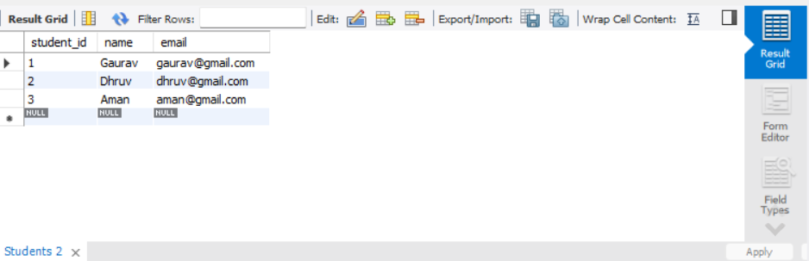

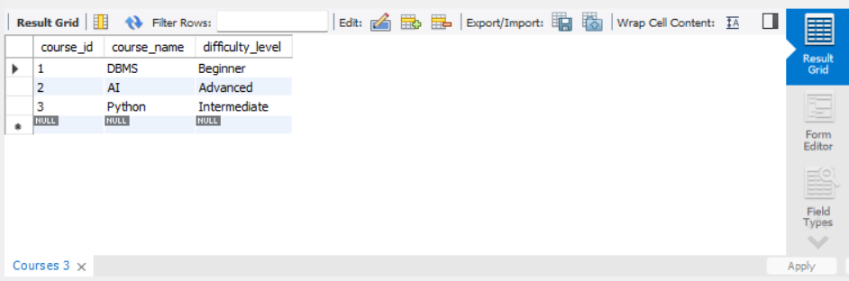

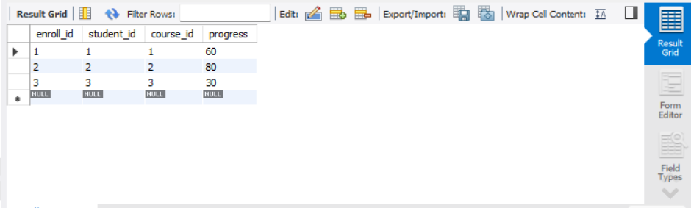

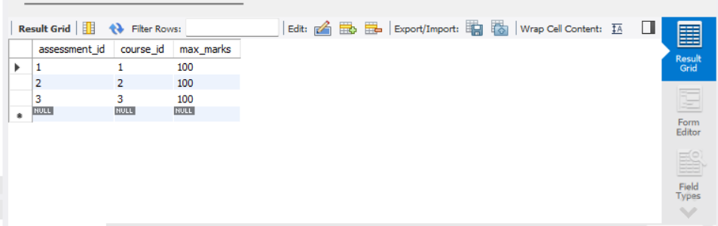

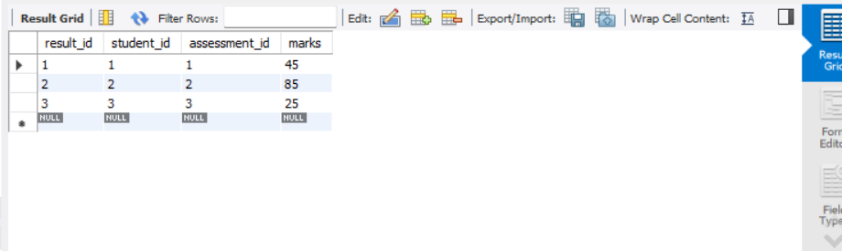

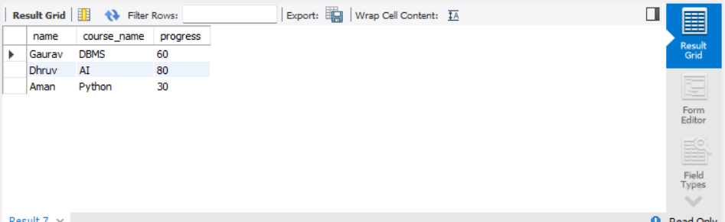

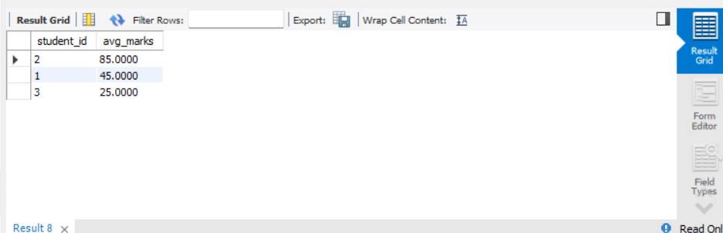

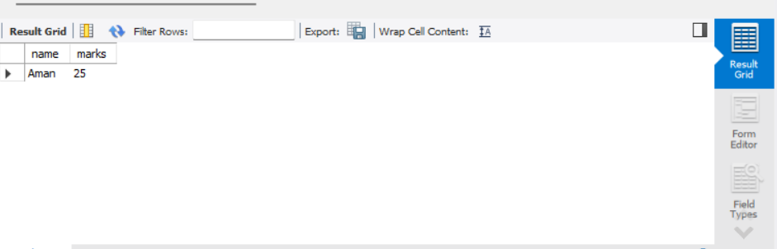

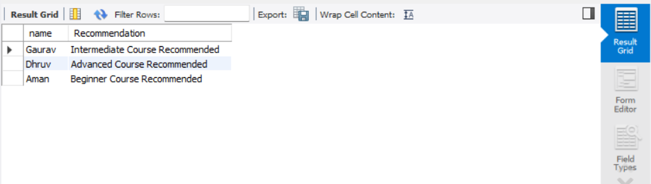

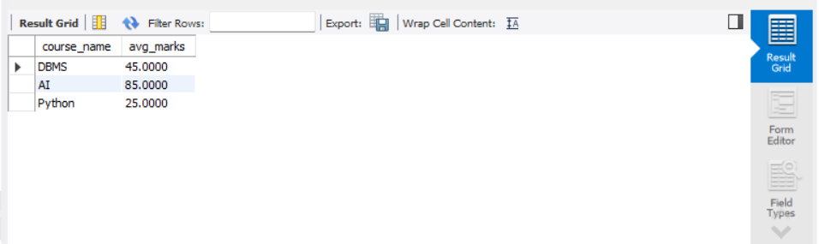

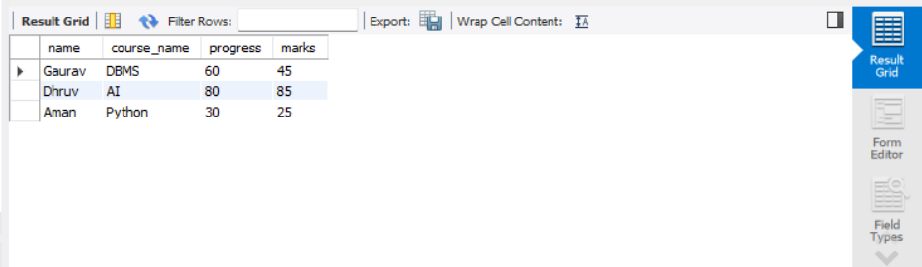

ADAPTIVE LEARNING LOGIC:
The system analyzes student performance based on marks.
If a student scores low, beginner-level content is recommended.
If performance is average, intermediate content is suggested.
If performance is high, advanced learning materials are provided.
This helps in personalized learning.

RESULTS AND ANALYSIS:
The database effectively manages students, courses, and assessments.
SQL queries help track progress and performance.
The system improves learning outcomes through adaptive recommendations.

ADVANTAGES:
- Personalized learning
- Efficient progress tracking
- Better student performance
- Easy data management
- Scalable system

LIMITATIONS:
- Depends on accurate data
- Basic recommendation logic
- No real-time tracking
- Limited automation

CONCLUSION:
This project shows how DBMS can be used in online learning systems.
By managing student data and analyzing performance, the system improves learning efficiency.
SQL queries play an important role in decision-making and personalization.

